##################

# BAR GRAPH -#

##################

# Clear the workspace

**rm(list = ls())**

**# NOTE:**

# Uncomment the code lines wherever required (Ex: Package installation..)

# set the working directory: Recommended

# It will enable in keeping all the plots in one location.

# use setwd() & getwd() functions

# Install & load the package " ggplot2 "

# install.packages("ggplot2")

**library(ggplot2)**

# Plot simple bar graph

**ggplot(mtcars, aes(x = factor(gear) ))+geom_bar()**

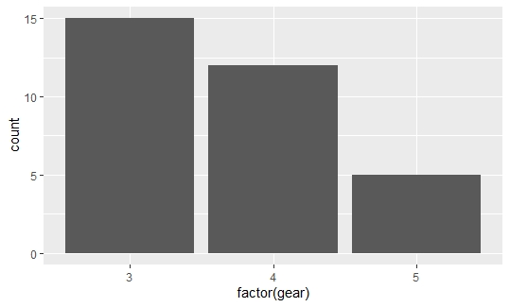

**ggplot(mtcars, aes(x = factor(gear),fill="red"))+geom_bar()**

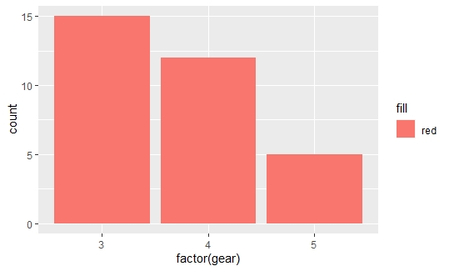

# adding contrast to the color

**ggplot(mtcars, aes(x = factor(gear) ))+geom_bar(fill="red",alpha=1)**

**ggplot(mtcars, aes(x = factor(gear) ))+geom_bar(fill="red",alpha=0.25)**

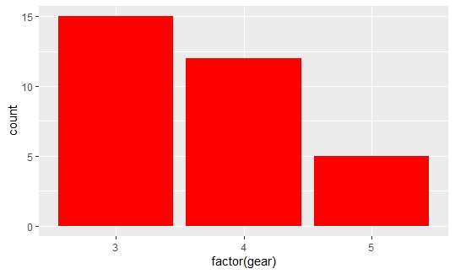

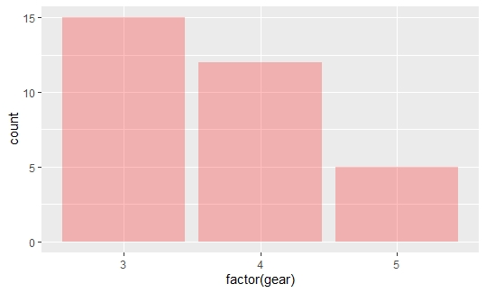

# Color each bar by group

**ggplot(mtcars, aes(x = factor(gear),fill=factor(gear)))+geom_bar()**

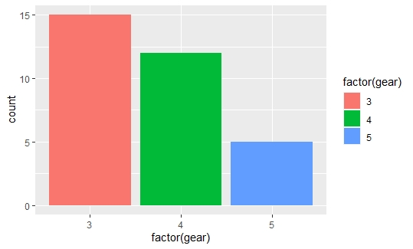

# Adding groups in the bar by cyl (4 6 8)

**ggplot(mtcars, aes(x = factor(gear),fill=factor(cyl)))+geom_bar()**

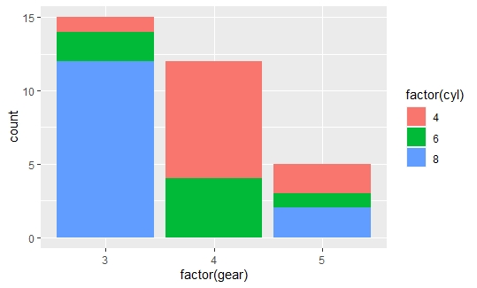

# Convert above graph into percentage bar diagram [ in two ways ]

**ggplot(mtcars, aes(x = factor(gear),fill=factor(cyl)))+**

**geom_bar(position = "fill")**

# OR

**ggplot(mtcars, aes(x = factor(gear),fill=factor(cyl)))+**

**geom_bar(position = position_fill())**

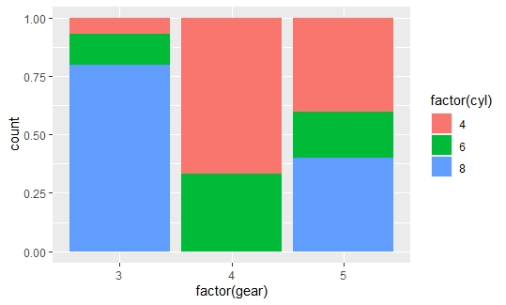

# convert into multiple bar graph [ in two version ]

**ggplot(mtcars, aes(x = factor(gear),fill=factor(cyl)))+**

**geom_bar(position = position_dodge())**

# OR

**ggplot(mtcars, aes(x = factor(gear),fill=factor(cyl)))+**

**geom_bar(position = "dodge")**

